TITLE I, PART A PROGRAM HANDBOOK

The information in this Handbook is subject to change.
Please check the online version routinely for any post-publication revisions.

Table of Contents

Introductory Statement 4

General Title I Information 5

Program Design 7

Components of a School wide Program 8

School Wide Plan 9

School Wide Personnel Program 11

Parent Involvement 12

Title I Advisory Council 15

Parent’s Right to Know 16

School Parent Compact 17

Concluding Statement 19

South Hancock Elementary School
Title I Overview

The purpose of this handbook is to provide beneficial information about the Title I program for the 2019-2020 school year at South Hancock Elementary School. South Hancock continues to provide high quality instruction and focuses on high expectations for all students. This is done by fostering high quality relationships, establishing school wide procedures, developing rigorous and engaging programs and lessons that are aligned with common core standards and working with our community, parents and other school partners to gain the resources needed to meet the needs of all of our children. The Title I coordinator and Title I teachers are always open to any questions you may have concerning the program provided through Federal Title I grants.

General Title I Information

Definition

The purpose of the Title I program is to make sure that all students have an equal, significant opportunity to obtain a high quality education and meet core academic standards regardless of their socioeconomic status and background. Formula grant programs are noncompetitive awards based on a predetermined formula. Title I is the largest program supporting elementary and secondary education in the new (ESSA).

Purpose

The Title I program was designed to help disadvantaged students reach the high academic standards set before them. Academic assessments and other indicators are used to annually review the process of each school.
Gap groups include All Students, White (non-Hispanic), African-American, Hispanic, Asian, Limited English Proficiency, Economically Disadvantaged (Free/Reduced Lunch), and Students with Disabilities.
The purpose of Title 1, according to Congress, continues to be to have substantially higher expectations for all students. The factors to accomplish this goal include high standards, enriched educational programs, school wide reform, effective professional development, coordination of services across agencies, involvement of parents, distribution of resources to areas where needs are greatest, improvement of accountability, and an increase of decision making authority and flexibility at the school level.
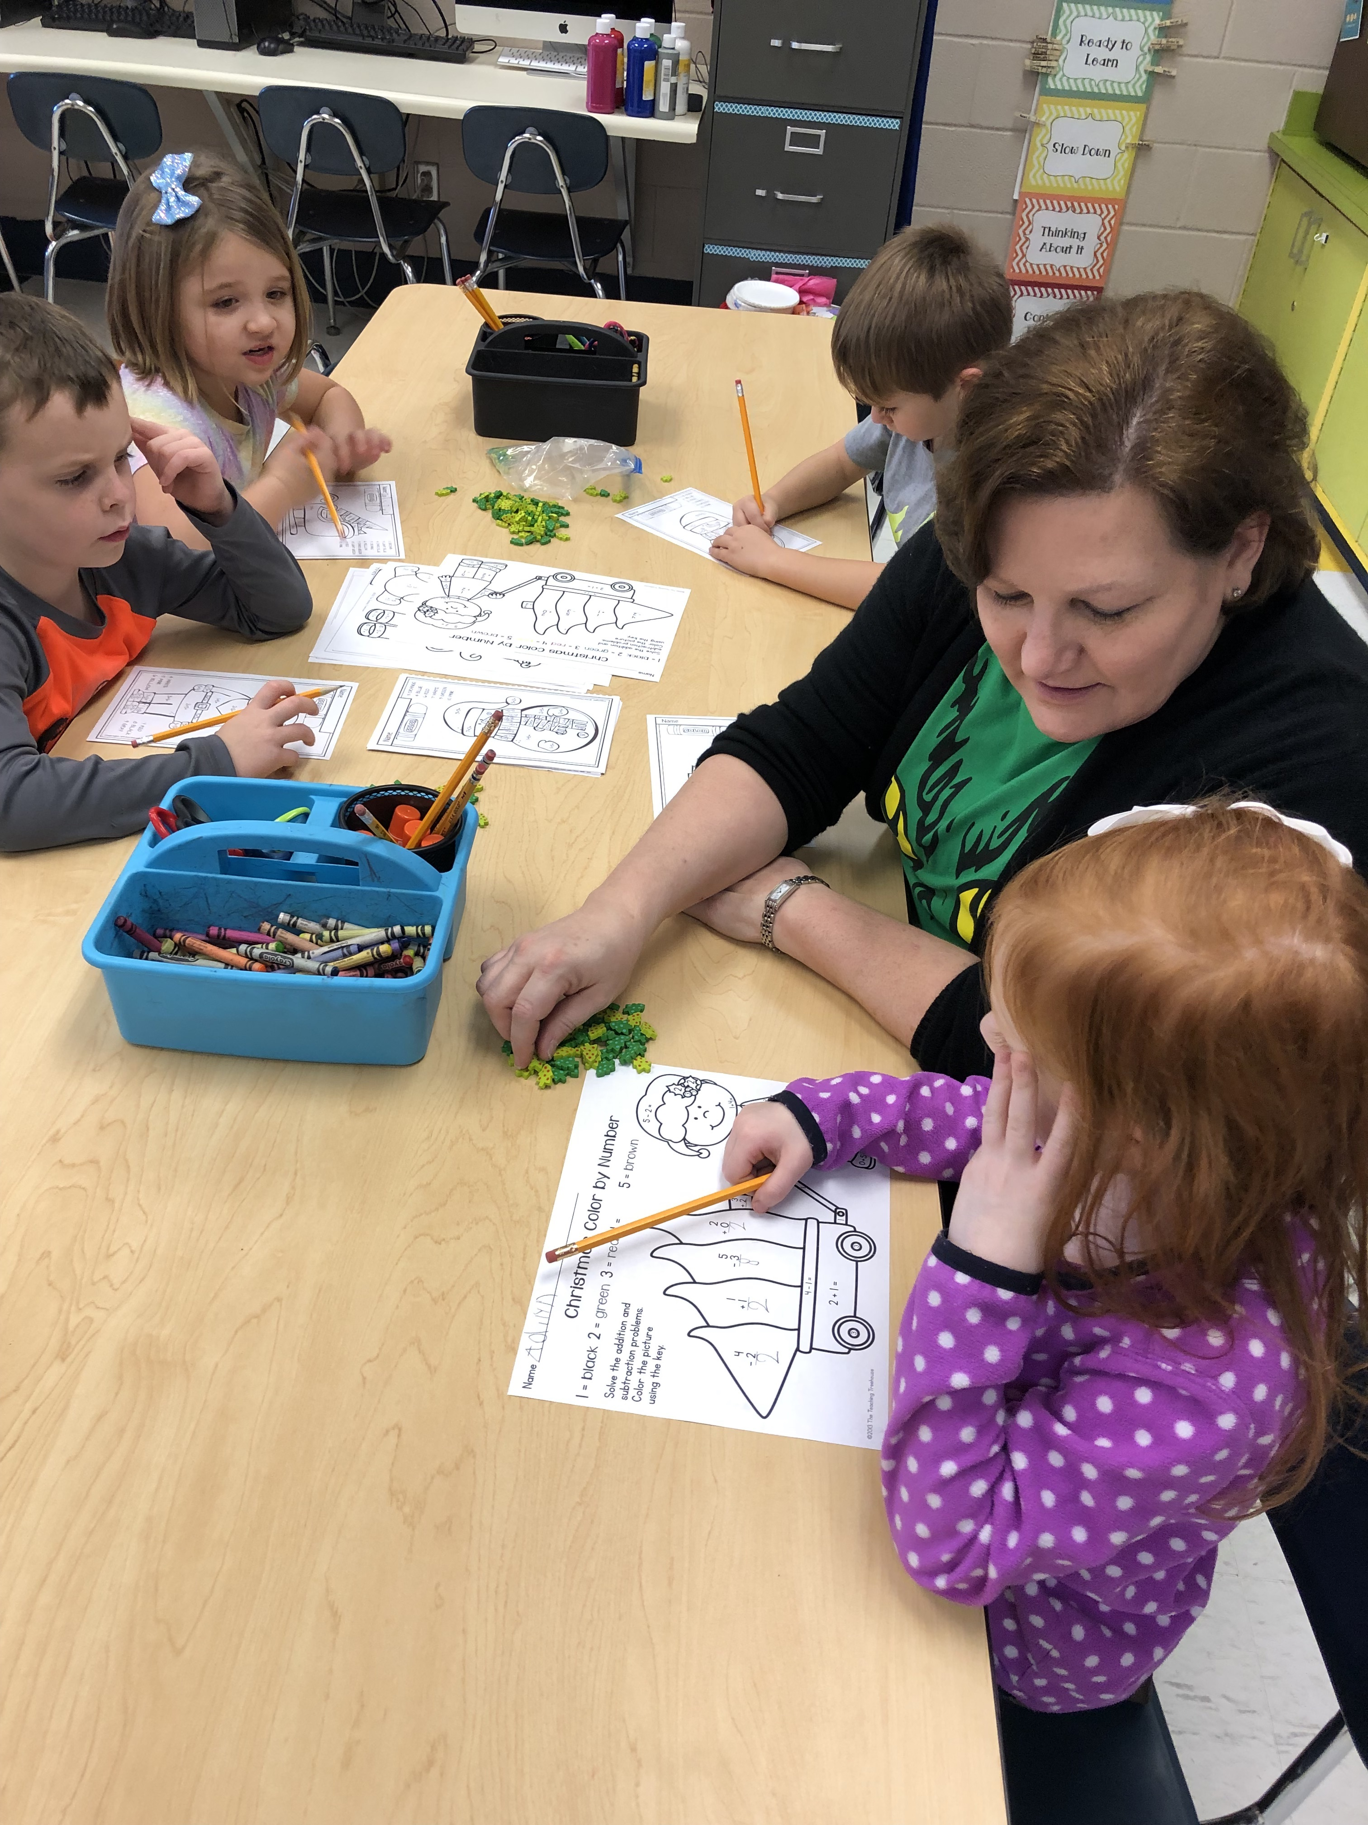
Program Design

South Hancock Elementary School is eligible to receive Title I funds as school-wide Title I program. All students at our school are eligible for the program and benefit from the program without having to qualify as individuals. South Hancock Elementary provides intense interventions for students who are at-risk in reading, math and writing. The staff continuously monitors the improvement of its students to ensure that students are adequately growing in all content areas by examining its scores on district and state assessments. Response to Intervention is implemented during each school day to provide extra support for students who are not mastering skills at their grade level or are not progressing appropriately on their academic standards. Students also receive additional supplementary learning through computer programs such as MAP, Compass Odyssey Learning, STAR, Accelerated Reader, and EPIC. Students are monitored frequently to ensure that progress is being made and meetings are held with classroom teachers, administrators, counselors and interventionists and to look at data to decide what students need the extra support of interventions based upon data of state and district assessments. A plan is put in place and goals are set to help these students make the growth they need to be successful and to address their individual needs.

Components of a School-Wide Program

A school with at least 40% low income is eligible to plan and implement a school-wide program. As a result the school must upgrade the entire educational program so that they are able to raise the standards of academic success for all students. The focus is on the instructional program of the school. As part of our comprehensive school improvement plan, South Hancock conducts a comprehensive needs assessment to determine the ongoing needs of the students throughout the school and how the school can successfully meet these needs by involving all stakeholders to maximize academic achievement for all students.

School-Wide Plan

During a one-year period (in consultation with the district, SBDM council, parents, staff and other members of the community) the school must include the following in the Comprehensive School Improvement Plan or in the School-wide Program Component Report:

The Comprehensive School Improvement plan must be:

School-wide Program Personnel

Qualifications for Teachers/Paraprofessionals in Title I Schools:
- All Title I funded teachers as well as all teachers teaching in core academic subjects taught in a Title I School must be Highly Qualified.
  - Highly qualified teachers are those who hold a bachelor's degree and a teaching license from their state, and who demonstrate competence in the subject areas they teach.
- All paraprofessionals working in Title I supported programs have earned a high school diploma or its recognized equivalent without regard to the date they were hired.
- All instructional paraprofessionals except for translation and parental involvement activities in Title I supported programs, meet the requirements of Section 1119, which includes: having obtained an associate’s (or higher) degree; or having met a rigorous standard of quality and was able to demonstrate, through a formal or state or local assessment-knowledge of, and the ability to assist in instructing, reading readiness, writing readiness, and mathematics readiness as appropriate.
- All instructional paraprofessionals in Title I supported programs are assigned appropriate duties consistent with responsibilities and limitations under Section 1119.
- All instructional paraprofessionals in Title I supported programs are working under the supervision of a teacher consistent with Section 1119.

Parent Involvement

Parents are encouraged to be actively involved in our school-wide Title I programs. Family and community members are provided opportunities to serve as volunteers in our schools, and are asked to serve as collaborative parents with the schools to meet the needs of our students. An annual parent survey is conducted at each school to allow parents to provide input regarding the Title I program. Parent volunteers provide many valuable hours of service to our school district, not only in direct assistance to students, but also in providing clerical help and support for extracurricular activities in our schools. For the protection of our students, all volunteers are required to complete a criminal background check before they are allowed to volunteer.

A Title I Parent Orientation meeting will be held for all parents of participating Title I students. This meeting can be held in conjunction with any other parent meeting the school offers. The purpose of the meeting is to explain activities, programs and procedures provided through Title I funds.

Expectations for Parent Involvement:
- Parents will receive information on how to access the Title I handbook.
- Parents are invited to observe their child in the classroom in accordance with Board Policy and school procedures.
- Parents will be given the opportunity to volunteer in the school. Parents should contact the Principal, teacher or FRYSC if they wish to volunteer.
- Volunteers must obtain a background check.
- Parents may obtain the schedule concerning adult education by calling the Adult Education Coordinator at 270-927-8066.
- Parents may obtain information regarding the school’s curriculum and national education goals by contacting the building Principal.
- Parents and administrators of participating Title I schools will be surveyed for evaluation of the current programs and input for future program development.
- Each school will provide an opportunity for parental input through the school-wide Title I Advisory Committee.
- A school-wide Title I Advisory meeting will be held in the spring to allow for parental input into the planning, design and implementation procedures of the School-wide Title I programs.

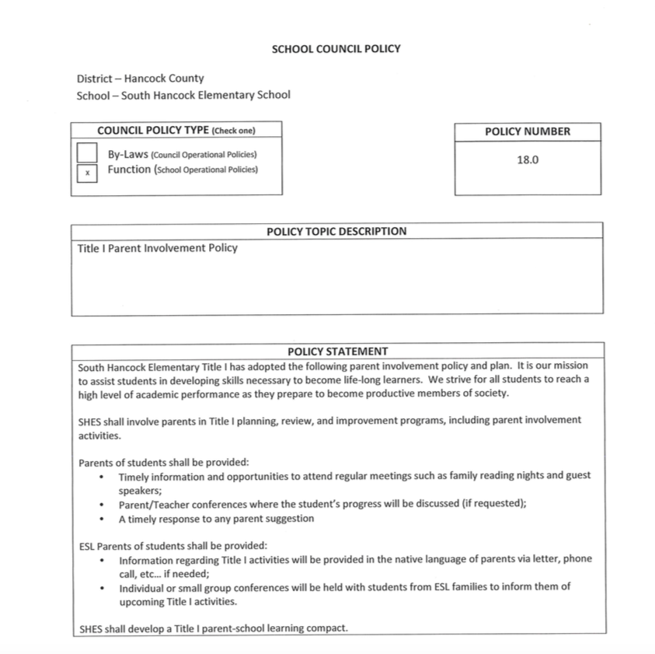
Title I Advisory Committee

The purpose of the Title I Advisory Council is to share concerns and provide input to the District regarding the Title I Program. The advisory committee will meet four times each year. At each meeting, information will be shared with the advisory council members about the Title I school-wide program, and the members are requested to provide input regarding any concerns that they may have regarding the Title I school-wide program.

2019-2020 South Hancock Elementary Title I Advisory Committee

- Principal
- Kim Mitchell, Classified Staff
- Dee Carter, Classified Staff
- Kim Porter, Parent/Certified Staff
- Michelle Tudor, Parent
- Lisha Williamson, Classified Staff
- Maribeth Franklin, Classified Staff

Parent’s Right to Know

Requirement 1: Parents may request and can receive essential information about the professional qualifications of their child’s classroom teacher(s).

Districts that receive Title I funds are required, at the beginning of each school year, to notify the parents of students attending any school that receives funds under Title I that they may request and the district will provide, at a minimum, the following information:

- Whether the teacher has met state qualifications and licensing criteria for the grade levels and subject areas in which the teacher provides instruction
- Whether the teacher is teaching under an emergency license or waiver through which the state qualifications or licensing criteria have been waived
- The baccalaureate degree major of the teacher and any other graduate certification or degree held by the teacher and the field or discipline of the certification or degree
- Whether the student is provided services by paraprofessionals and, if so, their qualifications.

School/ Parent Compact

A School-Parent Compact is an agreement among groups that firmly unites them. The South Hancock Elementary School-Parent Compact was developed jointly with school staff, students, and parents. As a school community, South Hancock Elementary will focus its School-Parent Compact on the academic standards to support all students and help them reach proficiency or beyond in reading, writing, and mathematics. Below are the ways each team member will be accountable for helping to achieve this goal. Our school/parent compact is pictured on following page.

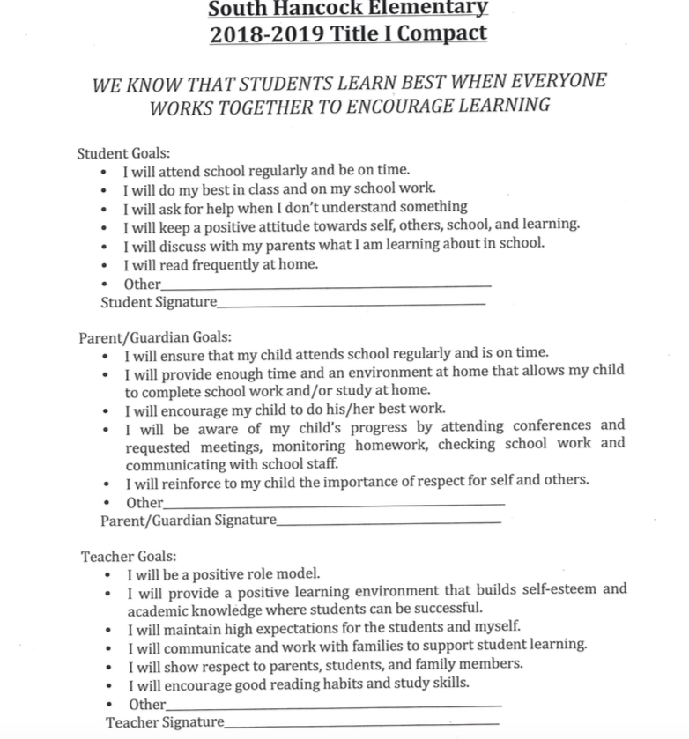
Concluding Statement

It is the goal of the South Hancock Elementary Title I program to provide support to the schools that will enable all students to succeed. If you have any questions please contact our Principal at 270-922-6726.

